NCC Education
Animators Hub: Design and Development of a Web-Based Platform for Sharing and Discovering Animated Contents
Computing Project
PROPOSAL
Edem Angel Edem Hogan
(P00193366)
AfriHUB
November 2026

Overview of the Computing Artefact
Animators Hub is a web-based information system: a web application on which animators share their work and viewers discover it. Animators upload a video with a title, a description and a custom thumbnail; viewers browse, search, watch, comment on and upvote that work; and both groups join communities and post messages to them. At present animators publish on YouTube, where their work competes for attention with every other kind of video on a saturated platform. A platform built only for animation gives less popular animators a better chance of being discovered, and discovered sooner. This project responds to that gap: animators need a space where animated work is the main content rather than one more video among millions.

Aim and Objectives, Scope and Architecture

Aim
To design and develop Animators Hub, a web-based platform that allows animators to share their work and allows viewers to easily discover it.

Objectives
- Enable a registered user to upload a video with a title, a description and a custom thumbnail.
- Enable viewers to browse videos and search them by title and description.
- Enable users to comment on videos and upvote them.
- Enable a user to create playlists and add videos to them.
- Enable users to join a community and post messages to it.

Scope
Features in scope
- User registration and login, required for uploading, commenting, voting and joining communities
- Video upload with a title, a description and a custom thumbnail
- Browsing and keyword search of videos by title and description
- Comments and upvotes on videos
- Playlists, including adding videos to playlists
- Communities, with membership and community messaging
- A responsive web interface that works in desktop and mobile browsers
Features out of scope
- Video transcoding and adaptive-bitrate streaming: videos play back as uploaded, and transcoding would need infrastructure and development time that a single-person project of this size cannot absorb.
- Native iOS and Android apps: a responsive web interface gives mobile access without doubling the build effort.
- Private messaging between individual users: messaging is limited to communities so that the feature stays bounded.
- Monetisation, live streaming and recommendation algorithms: each would be a project in its own right.

Architecture
The application will use a SvelteKit frontend, D1 for the database and R2 for storage, and it will be deployed on Cloudflare (Svelte, 2026; Cloudflare, 2026). Video files and thumbnails are held in R2, and the accounts, video metadata, playlists, comments, votes, communities and messages are held in D1.

Initial Literature and Existing Systems Review
Animated work is published today mainly on general-purpose platforms, and each of them answers only part of the problem. YouTube offers the largest audience, but that audience is also the difficulty: a short animation competes for attention with every other kind of video, and the recommendation system ranks content partly by how well it already holds viewers (YouTube, 2026), which works against an animator who has no following yet. Newgrounds has hosted independent animation since 1995 and keeps an audience that goes there specifically for it, but it is small next to the mainstream platforms and its browsing has changed little over the years (Newgrounds, 2026). ArtStation, launched in 2014, presents animation as part of a wider visual portfolio and suits stills and showreels well, yet it offers no discussion around a piece, so feedback on finished work moves off the site (ArtStation, 2026).
The literature divides into two parts. The first is discovery. Gillespie (2014) argues that platforms do not simply list content but rank it, and that the ranking decides what an audience ever gets the chance to see; a platform built for one medium can therefore rank that medium by its own criteria instead of general engagement. The second is usability. Nielsen's (1994) heuristics, among them visibility of system status and recognition rather than recall, describe what a viewer needs in order to browse and search without guidance, and they are the checks the interface will be reviewed against.
Two software engineering methods shape the plan that follows. Sommerville (2016) describes iterative development as delivering a working system early and refining it in repeated increments, which suits a project whose features are largely independent of one another. Clegg and Barker (1994) introduced the MoSCoW ranking used here to decide which requirements must be finished before time is spent on the optional ones. Neither method removes the need to keep the scope small: this review suggests that sharing, discovery and discussion are enough to test the idea, and the objectives are limited to that.

Risk Assessment
The main risks, and how each one is handled, are listed below.
- Upload size limits. Cloudflare rejects very large requests, so videos are uploaded straight from the browser to R2 instead of passing through the application server, and this is tested early in the first iteration.
- Time overrun. The two iterations are prioritised with MoSCoW, so a slip costs the optional features first, and the buffer weeks before submission absorb a short delay.
- Free-tier limits. D1, R2 and Workers all have quotas, so usage is watched during testing and the limits are raised if a demonstration needs more.
- Security weaknesses. Uploads are validated by type and size, every D1 query is parameterised, and only the owner of a video can delete it, following the OWASP Top 10 (OWASP, 2021).
- Unsafe or infringing uploads. Users can report a video, comment or message, an administrator can remove it, and the terms of use make the uploader responsible for owning the work.
- Loss of work. Every session ends with a commit pushed to a remote copy of the repository, and D1 is exported weekly so that a bad migration can be reversed.
- Illness or absence. Weekly supervision and the progress statements make a slip visible early, while the schedule still has room to absorb it.

Ethical Considerations
The project collects and publishes other people's work, so the following points are treated as requirements rather than good intentions.
- Consent and personal data. Registration collects only a username and an email address, passwords are stored as salted hashes, and no other personal data is collected.
- Data protection. The platform follows the Nigeria Data Protection Act 2023: users are told at registration what is stored about them and can ask for their account and uploads to be deleted (Federal Republic of Nigeria, 2023).
- Copyright. Uploaders confirm that they own the animation or have permission to publish it, and a takedown route is provided for rights holders.
- Harmful content. A report control is provided, the administrator can remove a video, a comment or a message, and the terms of use say so before upload.
- Honesty in the report. Test results, screenshots and feedback are reported as collected, and comments from animators are quoted only with their permission.
- Accessibility. The interface uses sufficient colour contrast, text alternatives for images and full keyboard navigation, in line with Nielsen's heuristics.

Work Breakdown Structure and Gantt Chart
The work is organised into two development iterations. Requirements are prioritised using MoSCoW so that the must-have features are completed first in each iteration.
Phase 1 begins on 10 May 2026 and ends with Phase 6 on 7 September 2026. Phases 5 and 6 overlap the build so that testing, writing and buffer time absorb a short slip without threatening the final submission.

Work breakdown structure
- Project management
- 1.1 Proposal written and approved
- 1.2 Weekly supervision and progress statements
- Requirements and analysis
- 2.1 Elicit requirements (review of comparable platforms; informal feedback from animators)
- 2.2 Prioritise requirements (MoSCoW)
- 2.3 Write analysis specification
- Design
- 3.1 Refine the requirements
- 3.2 Design the D1 data model
- 3.3 Write design specification (class, sequence and interface designs)
- Build
- 4.1 Set up the development environment (SvelteKit, Cloudflare, D1, R2, Git)
- 4.2 Iteration 1: accounts, video upload, video page, browsing and search
- 4.3 Iteration 2: comments, upvotes, playlists, communities and messaging
- 4.4 Deploy to Cloudflare
- Testing
- 5.1 Write unit and integration test scripts
- 5.2 Execute tests, fix defects and retest
- Report and assessment
- 6.1 Write final report
- 6.2 Prepare demonstration and presentation
- 6.3 Submit project
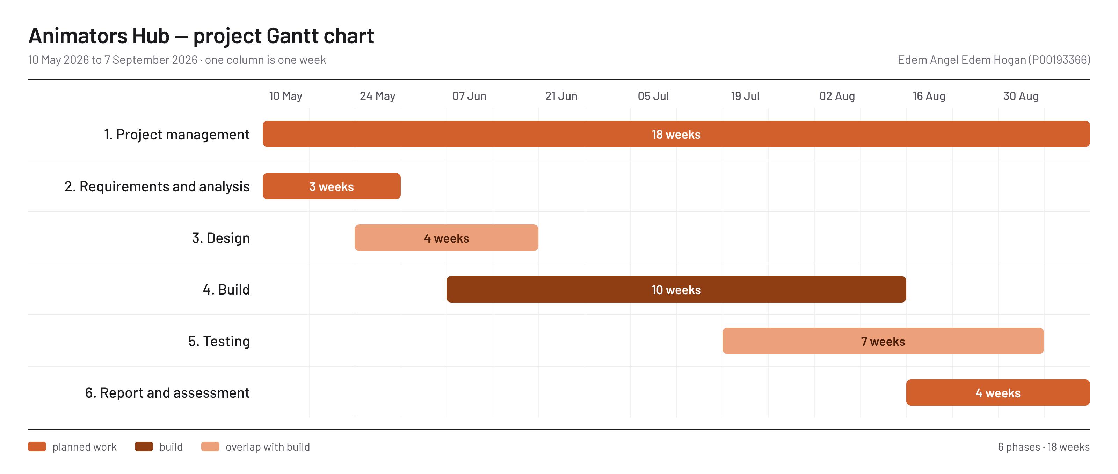
Figure 1: Gantt chart for the project

REFERENCES
ArtStation (2026) ArtStation: portfolio platform for artists. Available at: https://www.artstation.com (Accessed: 6 November 2026).
Clegg, D. and Barker, R. (1994) Case Method Fast-Track: A RAD Approach. Wokingham: Addison-Wesley.
Cloudflare (2026) Cloudflare D1 and R2 documentation. Available at: https://developers.cloudflare.com/d1/ and https://developers.cloudflare.com/r2/ (Accessed: 6 November 2026).
Federal Republic of Nigeria (2023) Nigeria Data Protection Act 2023. Abuja: Federal Government of Nigeria.
Gillespie, T. (2014) ‘The relevance of algorithms’, in Gillespie, T., Boczkowski, P.J. and Foot, K.A. (eds) Media Technologies: Essays on Communication, Materiality, and Society. Cambridge, MA: MIT Press, pp. 167–194.
Newgrounds (2026) Newgrounds: Everything, By Everyone. Available at: https://www.newgrounds.com (Accessed: 6 November 2026).
Nielsen, J. (1994) ‘10 usability heuristics for user interface design’. Available at: https://www.nngroup.com/articles/ten-usability-heuristics/ (Accessed: 6 November 2026).
OWASP (2021) OWASP Top 10:2021. Available at: https://owasp.org/Top10/ (Accessed: 6 November 2026).
Sommerville, I. (2016) Software Engineering. 10th edn. Harlow: Pearson.
Svelte (2026) SvelteKit documentation. Available at: https://svelte.dev/docs/kit (Accessed: 6 November 2026).
YouTube (2026) ‘How YouTube’s recommendation system works’. Available at: https://support.google.com/youtube/answer/9315727 (Accessed: 6 November 2026).

